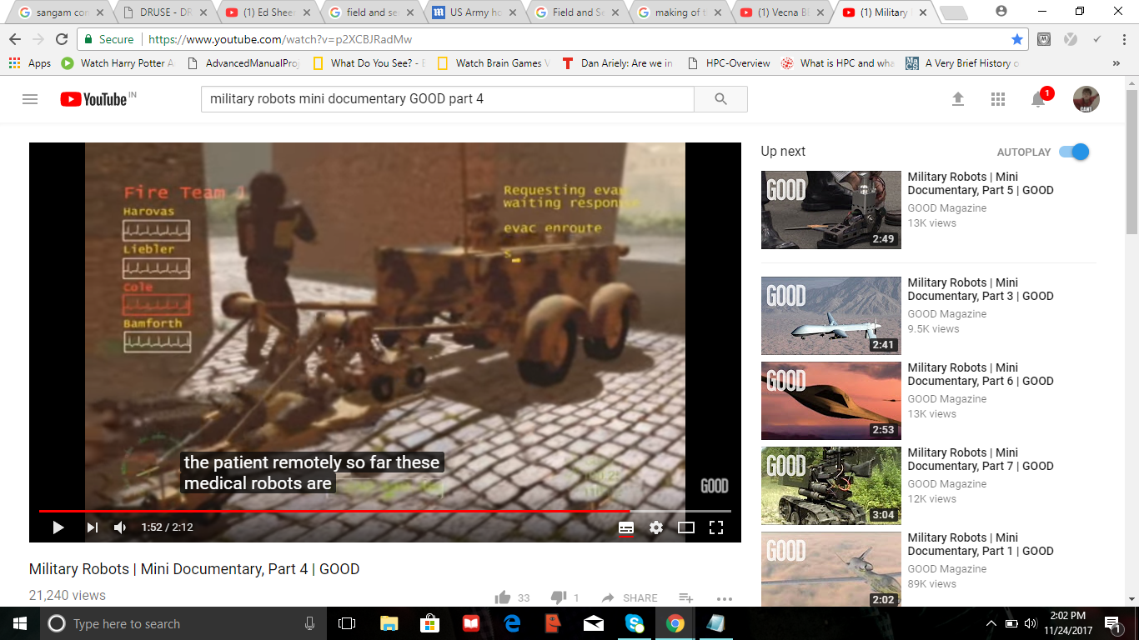

In most of the robots used for rescue of injured soldiers there are two parts involved. The first one is that actually carries the soldier back to the medical camp and the other that is used to load the soldier into the vehicle. The one in the picture is like that. We can implement the stretcher part easily, as u can see its two links joined together. The other assistant bot has two gripers kind which can grab the soldier and drag him onto the stretcher.

1. Another idea would be to carry the soldier as shown below but there it would be difficult to ensure soldier protection. This one is called the BEAR robot. The main challenge in this one would be to balance the bot when it lifts the person.

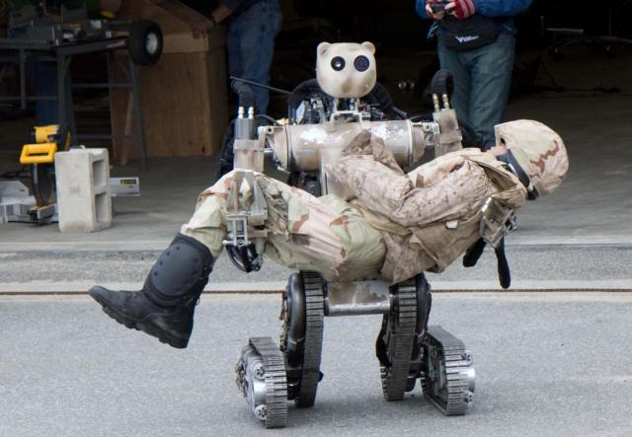

1. Another one I thought about includes rolling the soldier onto the stretcher by using an iron claw like the one used in garbage trucks but with rubber fitting to avoid hurting the soldier. It can be added to an already existing vehicle called ironclad. The only issue here might be that if the soldier is not on an even ground rolling the soldier might result in him falling down??

